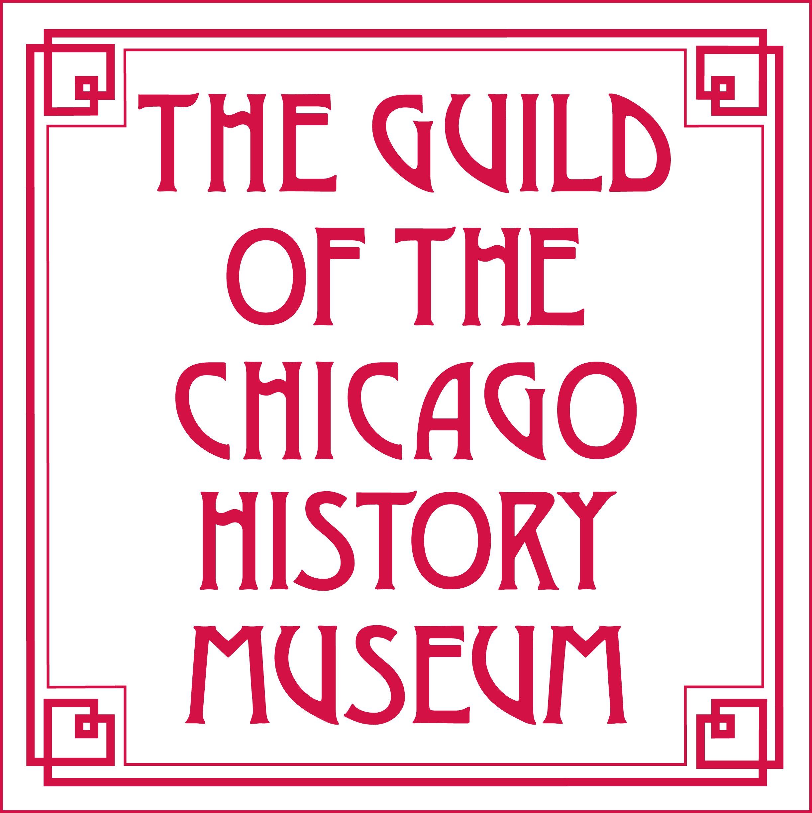

The Guild of the Chicago History Museum
New Member Nomination Form

Proposed Nominee: ____________________________________________________________________________________________________________
Nominee Address: ____________________________________City: ___State: ___ Zip: ________
Nominee Phone Number: (_____) Fax (if applicable): (_____) _________
Nominee Email: ________ Nominee Occupation: ______________ ________

Current Guild Member Sponsor:
Please describe your relationship to the nominee and why you are proposing her to The Guild:

____________________________________________________________________________________________________________________________________

Other Guild members who know the nominee (if any):

Sponsor Signature: _______________________________________________________________Date:________________________________________

Please send your completed nomination form to:
The Guild of the Chicago History Museum
Attn: Auxiliary Groups
1601 N. Clark Street
Chicago IL 60614-6038

For help with the proposal, or if there are any questions about the process, please call Kate Arias, 1st Vice President, Membership, at 708.275.9042, or email Kate at karias531@yahoo.com.

