What is Artivism?

Artivism looks like a funny word and many people may not know exactly what it means or stands for. Artivism is a portmanteau, or a word combining the sounds and definitions of two different words, in this case, art and activism. We know that art is what artists create, whether it is painters, muralists, musicians, among many others. We also know that activism consists of various methods and efforts by individuals and organizations to bring about social, political, environmental and/or economic change. When combined, art and activism, or artivism can be simply defined as the efforts of artists to bring about change through their art.
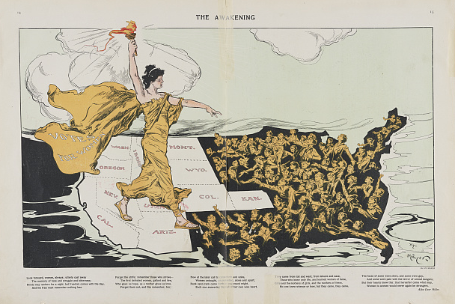
Art has always been an important part of social movements throughout history. Whether it is protest banners, political cartoons, protest songs, and even present-day social media art, art and artists have advocated for various causes. The Women’s Suffrage movement used posters and political cartoons to speak about and educate others about their cause. The right to vote was something that women did not obtain until 1920, only 100 years ago! Art helped get the suffragist’s message out to people. Unfortunately, many cartoonists and graphic designers were men in the early 1900s and it was not common for women to hold positions as artists for large magazines or newspapers. Even though men created many of the art and cartoons for the suffragist cause, women artists were present and using their creative skills for this movement. Charlotte "Lottie" Wilson Jackson, born in 1854, was the first African American to graduate the School of the Art Institute of Chicago and a women’s right activist and suffragette. Most of her paintings have been lost, but her 1902 painting of the meeting of Abraham Lincoln and Sojourner Truth survives and appeared on the cover of The Crisis magazine—in an issue devoted to women’s suffrage—the year after she past away.
The Awakening cartoon by Hy Mayer. 1915.
Library of Congress
Art was also integral to bring awareness to the AIDS Crisis in the 80s. ACT UP, or AIDS Coalition to Unleash Power, used various forms of art to make AIDS present in the public health discussion of the US. The illness was often ignored and not talked about because of its association with the LGTBQIA+ community. As cases began to rise, particularly in Black and Latinx communities, many AIDS activists, like Daniel Sotomayor of Chicago’s Humboldt Park, sought to
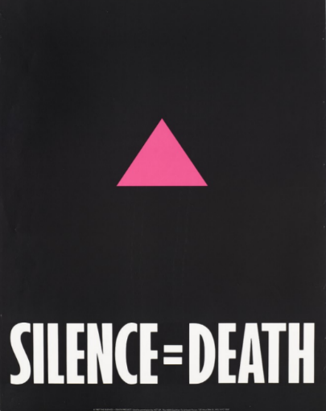
make their voices and stories heard and seen! Gran Fury was an artist collective, or a group of artists working together, that would design and create many posters and artwork that would be used by ACT UP and AIDS activists. Their most recognizable one is the black poster with a pink triangle and the quote “Silence=Death” written at the bottom. It was through the work of activists like Sotomayor and artists in Gran Fury that the AIDS Crisis was brought forward as an important public health crisis, although much more still needs to be done to this day.
Advertisement for the Silence=Death Project by ACT-UP, 1987. Wellcome Collection.
Music has also been an artform that artists and activists have used to convey their message and bring awareness to various causes. Chicago rapper and activist, Noname, has been an artist who uses their music to talk about the struggles of black folks in Chicago and nationally. Songs like Song 33 have Noname pushing for the police to be abolished and the absurdity of borders:
“It's trans women bein' murdered and this is all he can offer?/And this is all y'all receive?/Distracting from the convo with organizers/They talkin' abolishin' the police/And this the new world order/We democratizin' Amazon, we burn down borders.” (Song 33 by Noname)
Noname is just a most recent example of musicians and artists using music to speak on these issues. Older Chicago artists like Common and Lupe Fiasco have touched on these subjects in their music going back to the 90’s.
As we look at various examples of where art and activism intersect, it makes more sense as to why we need a term like Artivism. Art and artists are integral to social movements and are often the creative voices for these movements. Their work often expresses feelings that organizers and people cannot on their own! Activists know this and will often turn to artists for help in these organizing efforts, with many activists being artists themselves. In a world where there are still many injustices and change still needed, art is critical in communicating these issues and brining people together.

Comprehension Question:
- How would you define artivism? And what current examples of artivism can you think of? (Music, visual art, poetry, performance, etc.)

